3. TECHNICAL DISCUSSION AND DETAILS

3.1 DESIGN DETAILS

**OVERVIEW**

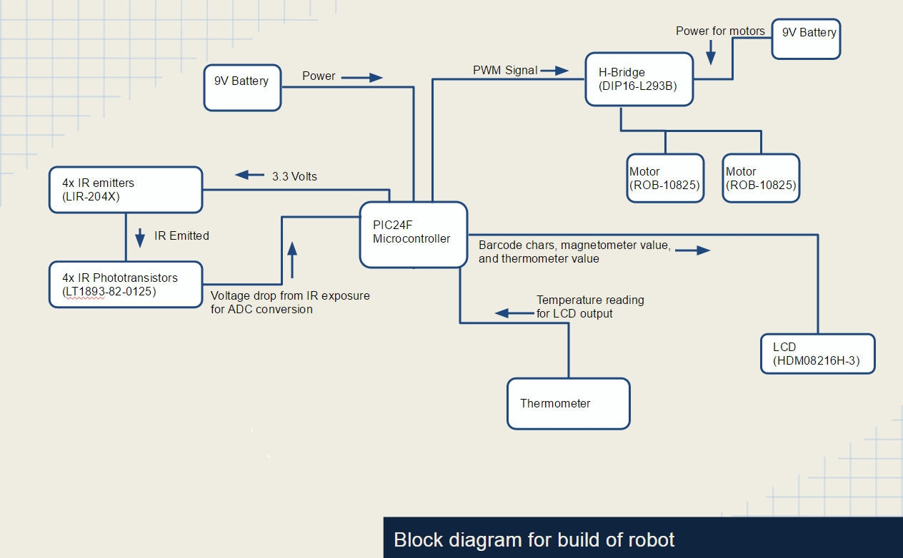The objective of this project is to successfully interface the PIC24FJGA002 and its modules with external hardware to build an autonomous, line-following robot. To program and connect to the PIC24F, a 16-bit, 28-Pin Starter Development Board (Part #DM300027) is used. For successful completion of the lab, several design requirements must be met, including: autonomous line-following, barcode detection and reading, U-turning, and the implementation of one additional feature, for which a thermometer was used. From the block diagram of the project design[1], it can be seen that the hardware and devices connected to the PIC24F are varied. The components of this diagram are discussed below.

• Figure 3A: Block Diagram for Robot Components

3.1.1 DESIGN DETAILS: HARDWARE

**CHASSIS/HOUSING[2]**

The central hub for this project is the Magician Chassis (Part #ROB – 12866). The PIC24F and the Development Board were mounted on top of the board along with the 8x2 LCD display (Part #HDM08216H – 3). Also on top of the chassis, to the rear of the robot, the H-Bridge (DIP16 – L293B), the TMP36 temperature sensor (Part #SEN – 10988), and some resistors were mounted to a vector board. On the bottom of the chassis, the following were mounted: two motors (Part #ROB – 10825), one omni-ball for stability, four IR emitters (Part #LIR – 204X), and four IR phototransistors (Part #LT1893 – 82 – 0125). The emitters and phototransistors were mounted to a vector board along with some resistors.

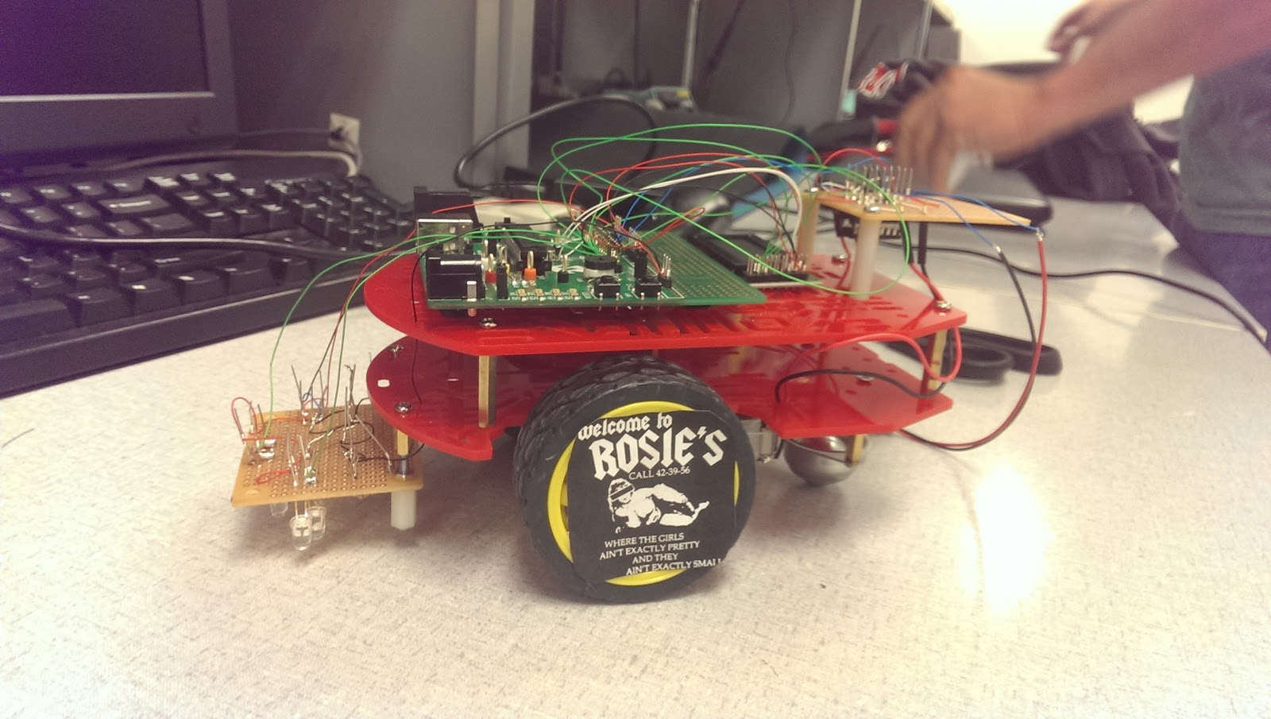• Figure 3B: Picture Overview of Robot

**POWER**

Powering the motors and the Development Board was done separately using two 9V batteries. To power the Development Board, a 9V to barrel jack adapter was used and plugged into the board’s auxiliary power port with jumper JP1 switched to “PWR SPLY.” The H-Bridge output to the motors was powered using another 9V battery, wiring voltage low directly to the four grounds of the H-Bridge (pins 4, 5, 12, and 13) and voltage high to the two chip enables (pins 1 and 2) and two voltage inputs (pins 8 and 16). Header pins were connected to the starter board at the left ground, 3.3V output, and 5V output to be used to power all other additional external components that required power.[3]

**INFRARED DEVICES LAYOUT: HARDWARE**

Three of the IR emitter and phototransistor pairs were installed in an isosceles triangle shape in the vector board attached to the bottom of the robot[4]. The middle pair was attached the furthest forward, while the left and right were in-line with one another, but recessed relative to the middle; the width between the left and right IR pairs was roughly the width of the track. On the right side of the same vector board, the fourth IR pair was soldered to the ends of two resistors, allowing them to protrude from the robot and read the barcode more easily. The voltage highs of all the emitters and transistors were connected and wired to the 3.3V pins on the Development Board, while the relative lows at the ends of the resistors were connected and wired to the ground on the left side of the development board. Each IR emitter was wired in series with a 47 k $Ω$, while the phototransistors were wired in series with a 410 k.[5] These resistor values were used to ensure that an appropriate amount of current flows through each IR component without burning-out the device.

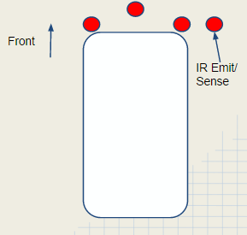• Figure 3C: IR Placement Schematic

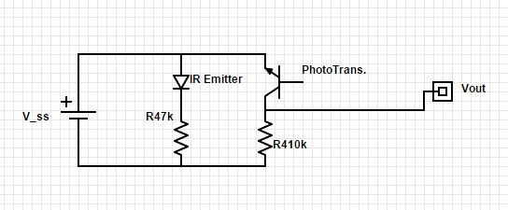

• Figure 3D: IR Pair Circuit Diagram

**MOBILITY: HARDWARE**

The robot’s movement was controlled through interfacing the H-Bridge with the Pulse-Width Modulation (PWM) module of the PIC24F and Development Board. Four of the PIC24F’s pins[6] (pins 17, 18, 21, and 22) were mapped using the output mapping registers RPOR4 and RPOR5. Using these pins, the output compare modules OC1 and OC2 were alternately set to provide a PWM signal to two of four pins[7] (pins 2, 7, 10, and 17) on the H-Bridge. The H-Bridge then translates these alternating output signals to power for the motors, turning the motors on and off using their respective motor highs and motor lows7 (pins 3 and 6 for the left motor; pins 14 and 11 for the right motor). Through alternating which pins were connected to the OC1 and OC2 modules, the robot’s movement could be controlled, using these values to determine right turns, left turns, all stop, and U-turning. The magnitude of the effective output voltage from the PWM is determined by the duty cycle, or the time that the signal is set high over one cycle’s period. Setting both motors to be forward and adjusting the PWM duty cycles, the robot can be turned due to one motor turning faster or slower than the other.

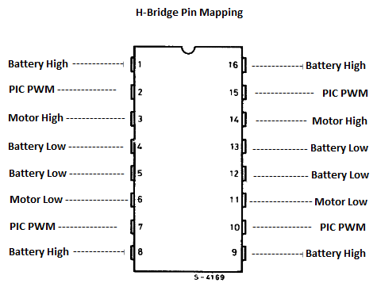

• Figure 3E: H-Bridge Pin Diagram

**TEMPERATURE READING: HARDWARE**

The additional component implemented in this project was a TMP36 analog temperature sensor. This device has three pins: a source voltage pin, an output voltage pin, and a ground pin. The high voltage was connected to the 3.3V output from the board, which was then passed through the sensor to its voltage output. A 45.3 k $Ω$ resistor was placed in series with a 10 k $Ω$ resistor and the voltage drop across the latter resistor was read and converted to a digital value using the ADC.[8]

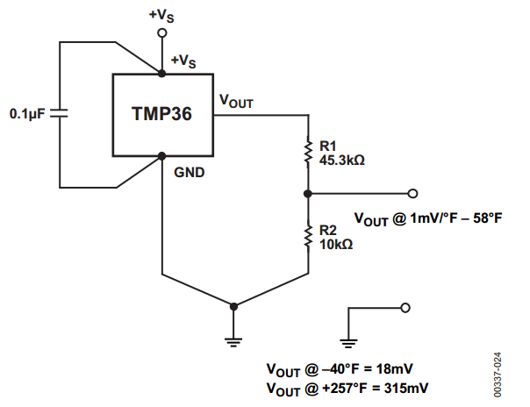• Figure 3F: TMP36 Circuit Diagram

**BARCODE READING: HARDWARE**

To read the barcode, the IR emitter and phototransistor pair on the right side of the robot[9] was utilized. A voltage of 3.3V was applied across the both branches of the pair, ensuring that the devices exhibited the same behavior as the IR pairs used for the line tracking functionality.[10] The voltage drop after the phototransistor was again converted into a digital value using the PIC24F’s ADC converter.

3.1.2 DESIGN DETAILS: SOFTWARE

**MAIN: OVERVIEW**

The main function for this project hosts the pin assignments and the switch/case statement that controls which maneuver to perform (ie: right turn, left turn, stop, etc.). To begin, the TRIS register is set to have RB8, 9, 10, and 11 to be output; these are the pins that correspond to the RPORx pins used to output the PWM signal to the H-Bridge for motor control. Following these declarations, the analog pins that are used for the ADC are set, first by setting the TRIS to be input, and then by setting the AD1PCFG register to be in analog mode. The basic functionality switch 1 is also set, setting it to be input and enabling the change notification for the corresponding pin. Afterward, the ADC control is set to auto-sample but to have no inputs scanned. For choosing which ANx pin to read the ADC from, the AD1CHS register was used and ADC1BUF0 was continually read from. The last code before the main “while” loop are the initializations for the LCD and PWM.

The while loop begins by converting and reading all the phototransistor readings through the ADC. Each pin is read sequentially from ADC1BUF0 with a 200 microsecond delay between readings to ensure that ample time has passed for the ADC to have switched input channels. The “barCode_Scan” function is called each time the while loop executes to act as a polling function, continually checking if a barcode has been detected or is being read.

**MOBILITY: SOFTWARE**

The speed of the robot was controlled through adjusting the PWM output values to supply a different effective voltage to one or both of the motors depending on the type of maneuver that needed to be executed. Controlling the duty cycle values was done through an analog-to-digital conversion (ADC) of the voltage drop across the phototransistors. When the ADC value was less than 250, it was determined that the phototransistor was over the black tape, and when it was above 550, it was determined to be over the tile. During the transition from black to tile, the ADC value began to gradually increase until its maximum, and vice versa. From these values, an algorithm was used to control the motors independently of one another in a smooth, even manner.

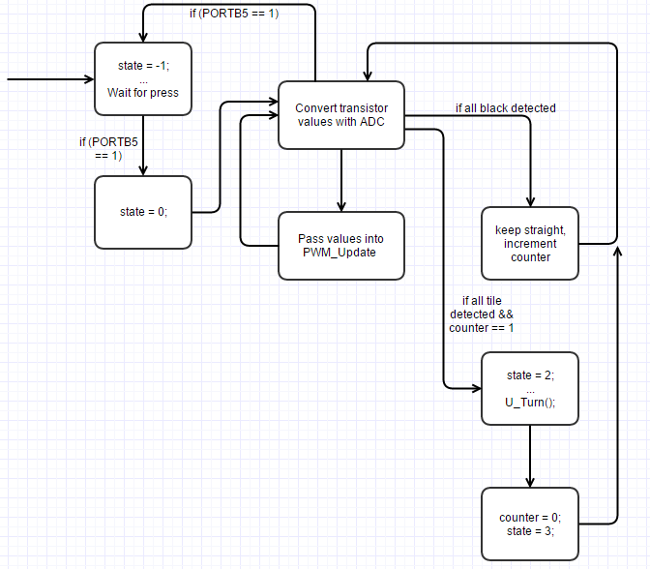• Figure 3G: Line Following Flowchart

1. See Figure 3A.
2. This section references the picture shown in Figure 3B.
3. See Figure 3E for H-Bridge pin mapping.
4. See Figure 3C for IR pair layout.
5. See Figure 3D for IR circuit design.
6. See Figure __ for the PIC24F pin mapping
7. See Figure 3E for H-Bridge pin mapping.
8. See Figure 3F for the schematic of the temperature sensor circuit.
9. See Figure 3C for the IR layout.
10. See Figure 3D for the IR circuit diagram.